MACH4METAL

metalworking machinery
Transito 21
6909 DA BABBERICH Netherlands
Tel. +31 (0)316-247123
Fax: +31 (0)316-247956
info@mach4metal.com
www.mach4metal.com

Bank No : 66.52.13.883
IBAN : NL33 INGB 0665 2138 83
BIC : INGBNL2A

COMAC GALILEO 40 Profile
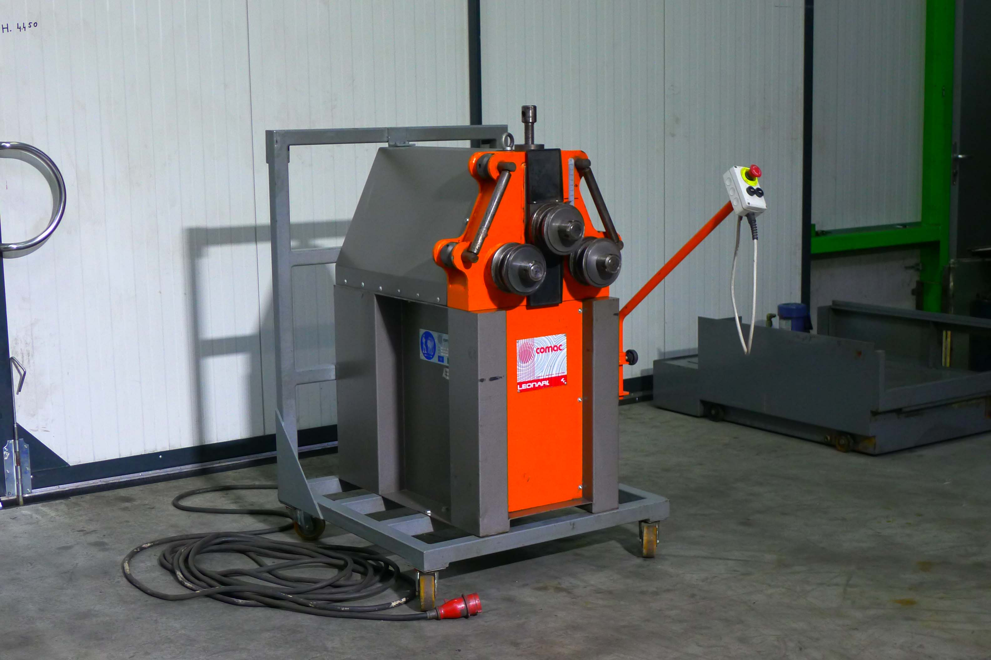
- Make : COMAC Italia
- Type : Galileo 40 PM
- Serial No. : 400398
- Age : 2011

- Ø shaft diameter : 40
- Ø roll diameter : 145

- Bending speed : 3.7 M/min
- Power : 1.1 kW
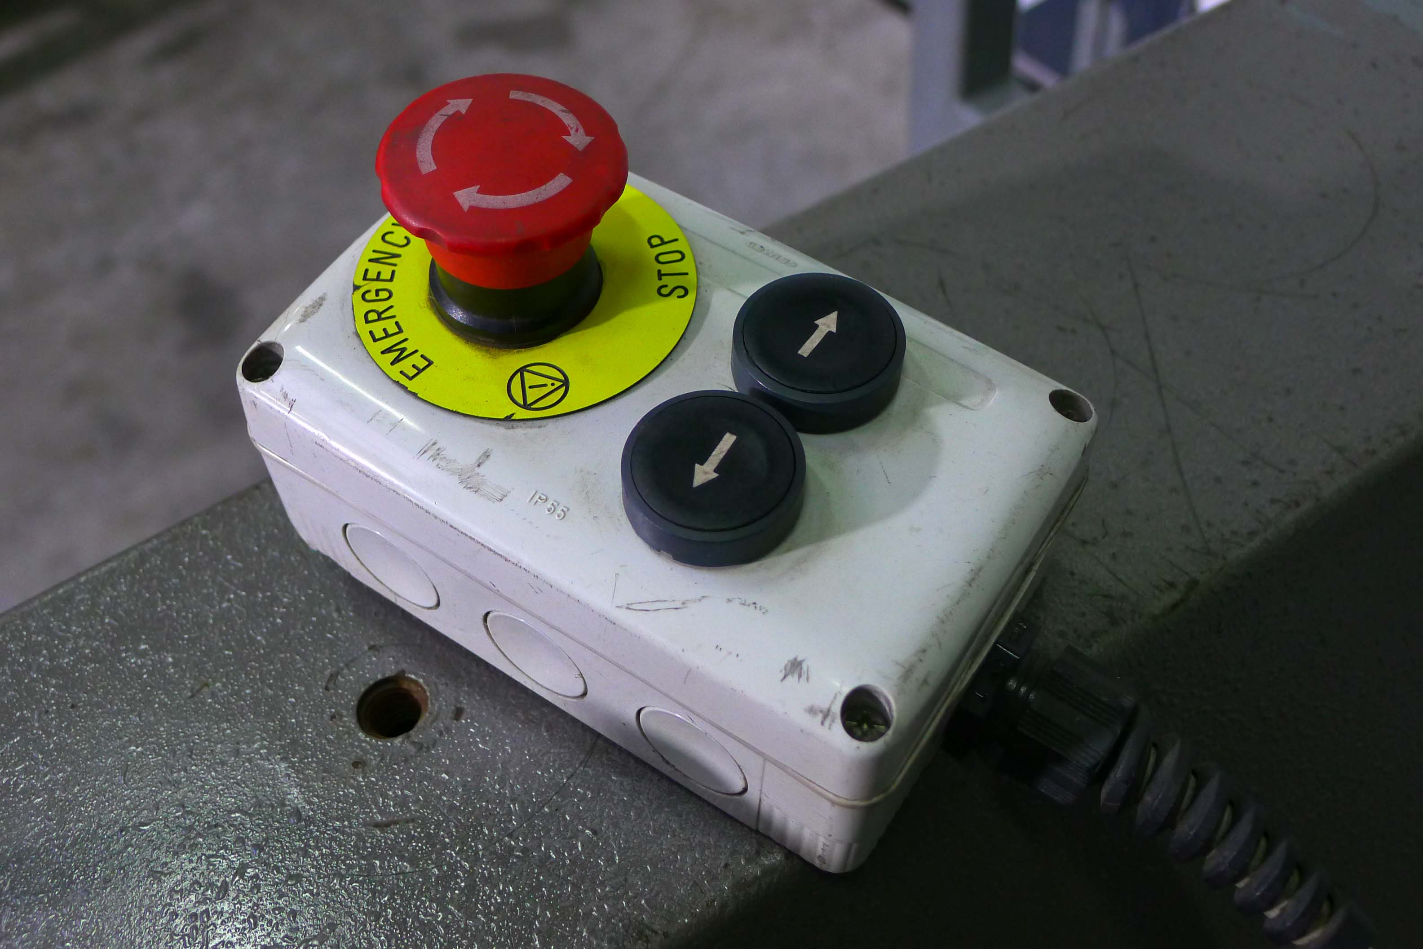

- Max. section modulus : 6 cm³
- Weight : 370 Kg

- Angle 25 x 3 R Ø 400
- Flatt 60 x 10 R Ø 600
- Tube 70 x 2 R Ø 2.000
- Bar 35 x 35 R Ø 600

- Dimensions
- Length : 980
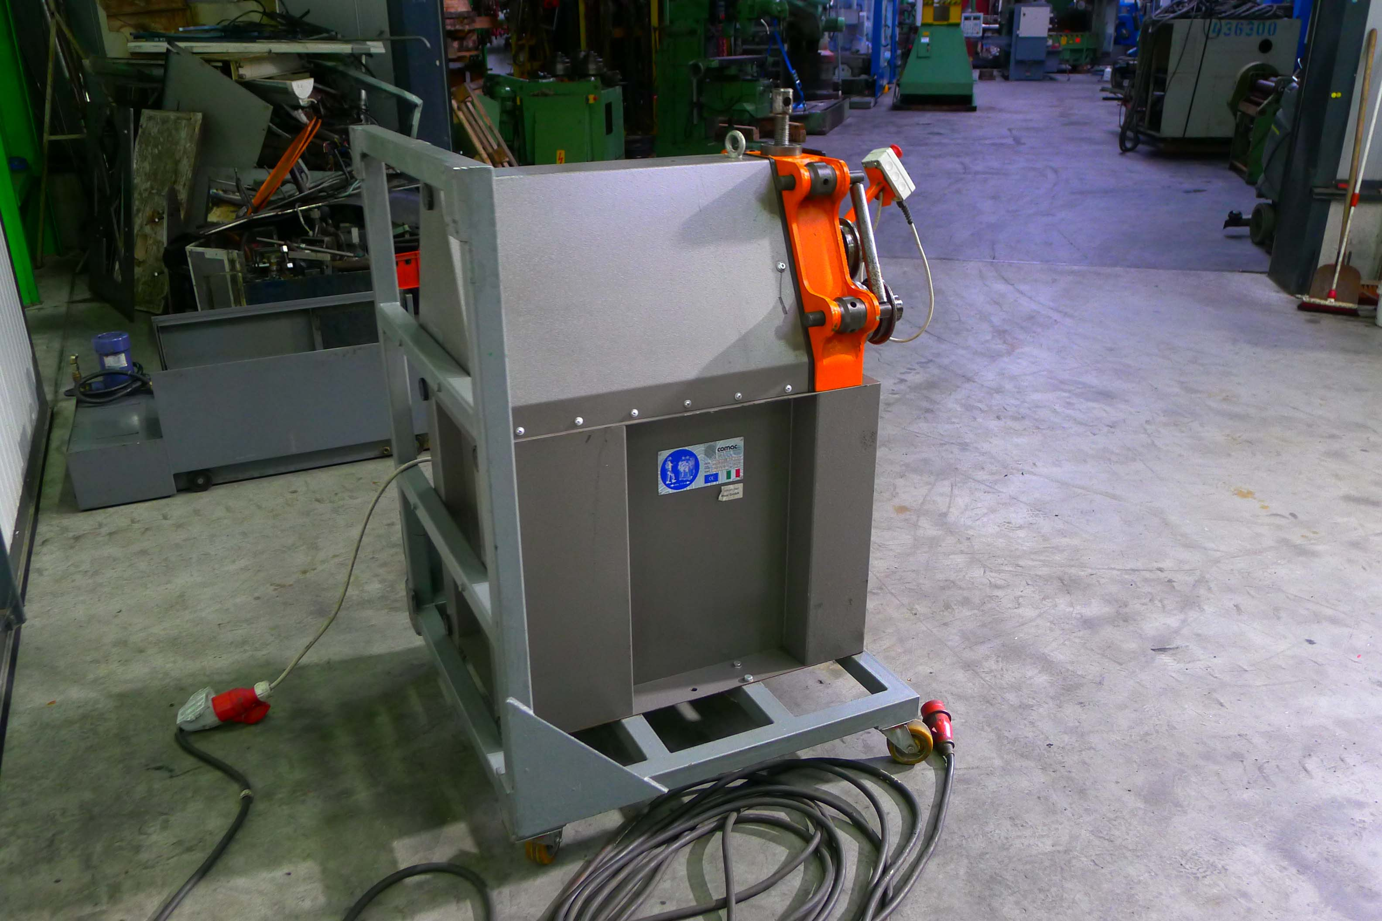
- Width : 620
- Height : 1.160
- Weight : 370

- Incl. manipulator for Horizontal and
Vertical bending

Please Note: The above information has been obtained to the best of our ability and belief from, and from the manufacturers where possible. It is given in good faith, but its accuracy can not be guaranteed. Accordingly, it will not form a representation or constitute contractual terms. We advise you to check any vital details!

